MODULE 00
Foundations & Mindset
Exercise Workbook
SDET Career Path Guide · 6 Topics · 18 Exercises
Complete each exercise in the answer boxes provided.

Topic 1 · Why Test Automation Matters
The core insight: manual testing scales linearly with the product; automation scales with engineering effort. The goal of these exercises is to make that abstract claim concrete using your own team's numbers.

EXERCISE 1 — ROI CALCULATION
Pick one manual flow your team runs on every release. Use the table below to capture your baseline and calculate the automation payback period.

Metric | Your Numbers
Flow name / description | Fill the format with 5 required fields in 12 languages covering 3 scenarios per field: field filled, empty field, min or max limit.
Estimated time per manual run (hours) | 24
Number of releases per year | 48
Total manual cost per year (hours) | 576
Estimated one-time automation build (hours) | 120
Automation run time per release (minutes) | 180
Break-even point (# releases) | 10.47

Formula: Break-even = Build cost ÷ (Manual time − Automation time per release)
Hourly rate assumption: $50/hour
Build Cost: 120hrs*50perhrs = $6000
Break-even = 6000 ÷ (576hrs – 3hrs) = 10.47
2 releases per month = 5.23

EXERCISE 2 — WHAT NOT TO AUTOMATE
Identify one flow in your product that should NOT be automated yet. A good candidate is too volatile (changes weekly), too low value, or genuinely hard to stabilize.

Flow name:
Conference Rooms Online

Reason it should stay manual (volatile / low-value / hard to stabilize / other):
For the design there’s always different format and text related, since different clients has different reasons for the conferences and client force the design and format of the conference

What signal would change your mind? (e.g., 'if the UI stabilizes for 2 sprints')
Generate standard design with different views, for different range of budgets and include edge designs for VIP clients

Topic 2 · The Automation Pyramid
The pyramid (Unit → Integration → API → E2E) exists because cost and feedback time grow as you go up. These exercises ask you to map your current suite against the ideal shape and find misplaced tests.

EXERCISE 3 — SKETCH YOUR CURRENT PYRAMID
Count the tests in your project at each level (approximate is fine). Fill in the table, then note whether your shape is healthy or inverted.

Level | Ideal % | Your Approx %
Unit | ~50% | 20
Component / Integration | ~25% | 20
API / Contract | ~20% | 5
E2E / UI | ~5% | 55
TOTAL | 100% | 100%

Overall shape assessment (healthy pyramid / inverted / flat / other):
At the momen of leaving the proyect the E2E was fully covered and it was starting to work on API, the project was mainly focused on filling the fields from a format in 12 languages.

EXERCISE 4 — FIND A MISPLACED E2E TEST
Find one E2E test in your suite that is really asserting a business rule (discount math, validation logic, error code). Describe it below and sketch how you would move it down.

Test name / file:
Report Inventory of all the records in a month

What business rule does it assert?
The data inserted on the formulary should be mapped correctly on the results for all records gathered.

Which level should it move to? (Unit / Integration / API)
The mapping for the reprot can be part of the integration

Sketch the new test in pseudocode or plain language:
Create a query to extract all record of latest month
Use CSV or JSON file to export it to the Excel
Mapp correctly the report and records inside the Report

EXERCISE 5 — BUG → LEVEL MAPPING
Pick one bug from the last sprint. Identify the earliest level at which a test could have caught it.

Bug description:
A PROD only bug for loading data, insuficient memory

Earliest level that could have caught it:
If it’s from the first step it should be consider an increasing memory capability, on the testing side a STAGE environment should be exact mirror of PROD site – Integration phase if we are talking about pyramid

Why that level (and not a lower or higher one)?
To minimize the impact on production having issues on loading data

Topic 3 · Types of Automation Testing
The testing toolbox has at least 10 distinct types. Knowing which to reach for — and which your team is skipping — is a core SDET skill.

EXERCISE 6 — BUG-TO-TYPE MAPPING
Take 5 recent bugs from your issue tracker. For each one, identify which test type would have caught it earliest.

Bug (short description) | Test type that would have caught it earliest | Tool example
1. Tooltip Missplaced | E2E Test | Playwright
2. Search results not able to match a report | Integration Test
3. Records submitted on the formulary are not reflected on DB | Integration Test
4. Options not displayed on selecting a specific chekcbox | Component Test
5. Link redirects to 404 error page | E2E Test | Playwright

EXERCISE 7 — THE MISSING TYPE
Identify one test type your team is not doing at all. Sketch the smallest first investment you could make to introduce it.

Test type your team is missing:
Automation Testing

Why it is currently skipped (no tooling / no time / no awareness / other):
No full knowledge of how to automate, and best and easiest tools to use, plus budget instead of limited licenses

Smallest first investment: one tool, one test. Describe it.
Start with prompt design and using Playwright as a tool

EXERCISE 8 — ACCESSIBILITY SCAN
Run an axe-core or Lighthouse scan on a page you own. Triage the top 3 findings below. Using the site https://istqb.org/

Finding | Rule / ID | Severity | Proposed fix
1.Some elements have a tabindex value greater than 0 | A value greater than 0 implies an explicit navigation ordering. Although technically valid, this often creates frustrating experiences for users who rely on assistive technologies. | Serious | The first method is to change the tabindex to 0. The second method is to remove the tabindex entirely and modify the structure of the page so that a user tabbing through elements reach them in the order initially desired.
2. Links Rely on color to be distinguishable | Low-contrast text is difficult or impossible for many users to read. Link text that is discernible improves the experience for users with low vision. | Serious | Success Criterion: Ensure color contrast of at least 3:1 for link text.
3. aria-* attributes do not match their roles | Each ARIA role supports a specific subset of aria-* attributes. Mismatching these invalidates the aria-* attributes. | Critical | The detailed information on each attribute can be found by looking at the documentation for each role and/or each attribute.

Topic 4 · Non-Functional Testing
Non-functional tests answer "does it work well enough?" — under load, securely, and accessibly. The pattern: agree on an SLO before writing a single test.

EXERCISE 9 — DEFINE YOUR SLO
Pick one critical endpoint or page in your product. Define its Service Level Objective (SLO) before writing any tests.

SLO Dimension | Your Target
Endpoint / Page | GET /api/products?page=1
P95 latency target (ms) | 400 ms
Error rate budget (%) | 1%
Target concurrent users / RPS | 100 virtual users
Test duration (minutes) | 3 minutes

EXERCISE 10 — K6 LOAD TEST
Using the SLO above, write a k6 test script. Use the template below — fill in your values.

// load.js — k6
import http from 'k6/http';
import { check, sleep } from 'k6';
export const options = {
vus: 100, // your concurrent users target
duration: '3m', // your test duration
thresholds: {
http_req_duration: ['p(95)<400'], // your P95 SLO
http_req_failed: ['rate<0.01'], // your error budget
},
};
export default function () {
const r = http.get(' https://istqb.org/');
check(r, { '200 OK': r => r.status === 200 });
sleep(1);
}

After running: what was your actual P95? Did the test pass or fail the SLO?
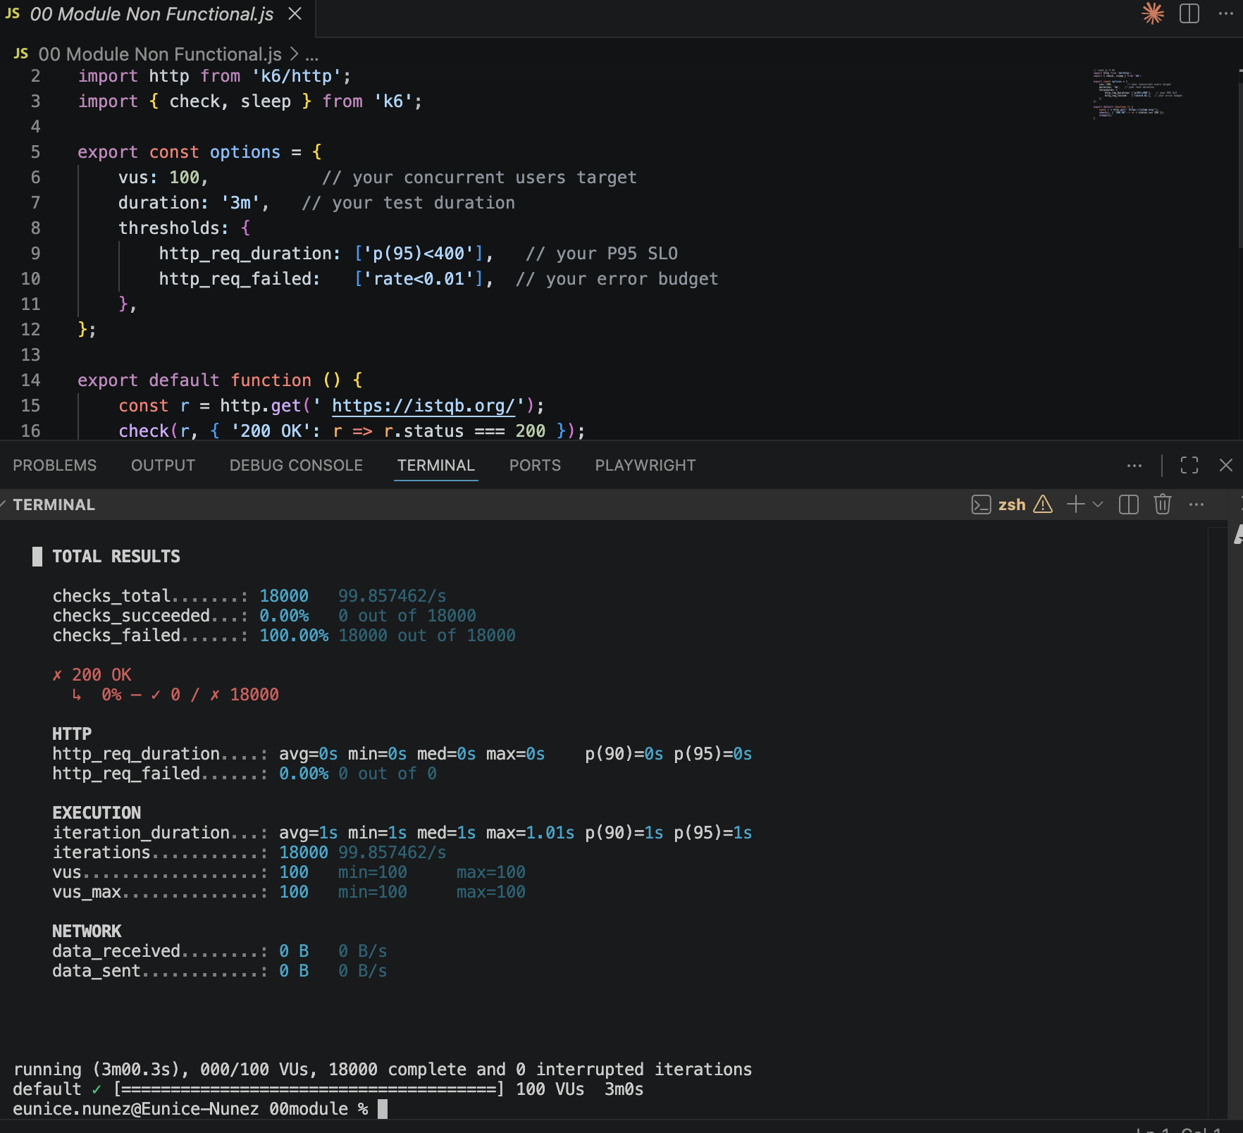

EXERCISE 11 — LIGHTHOUSE AUDIT
Run a Lighthouse audit on a page you own (Chrome DevTools → Lighthouse tab). Record the four scores.

Category | Your Score | Target (>) | Top issue found
Performance | 68 | 90 | Document request latency
Accessibility | 86 | 95 | Aria attibutes do not match their roles
Best Practices | 96 | 90 | Issues were logged in the Issues panel in Chrome DevTools
SEO | ! | 90 | SEO links are crawable, have a descriptive text

One concrete improvement you would make based on the audit:
Identical links have the same purpose

Topic 5 · API Automation vs Front-End Automation
API tests answer 'does the backend behave correctly?'. E2E tests answer 'does the UI render and bind correctly?'. The discipline is never asserting a business rule through 5 page navigations when one POST proves the same thing.

EXERCISE 12 — AUDIT YOUR E2E SUITE
Pick 5 E2E tests from your suite. For each, decide: should this be replaced or shortened with an API test?

E2E test name | What it really asserts | Move to API? (Y/N) | Reason
test_empty_cart_shows_zero_total | Cart total math is 0 when no items | Y | Pure business logic — a unit test or API test can assert this in milliseconds
test_invalid_coupon_shows_error_msg | Backend rejects bad coupon code | Y | The rejection logic lives in the API; the UI just displays whatever the API returns
test_checkout_flow_completes | Full purchase journey works end-to-end | N | Only E2E can verify the full wiring: UI -> API -> payment -> confirmation page
test_password_min_length_validation | Form rejects passwords under 8 chars | Y | Validation rule — can be covered by a unit test on the validator function
test_product_page_loads_correctly | Product name and price render on the page | N | UI rendering and data binding — must be verified in a real browser

EXERCISE 13 — CONVERT ONE TEST

Original E2E test (test_invalid_coupon_shows_error_msg):
// Playwright E2E — takes ~8 seconds
test('invalid coupon shows error', async ({ page }) => {
await page.goto('/cart');
await page.fill('#coupon-input', 'FAKECODE');
await page.click('#apply-coupon-btn');
await expect(page.locator('.error-msg')).toHaveText('Invalid coupon code');
});

New API test (same assertion, much faster):
// Supertest API test — takes ~80ms
it('rejects invalid coupon with 422', async () => {
const res = await request(app)
.post('/api/cart/apply-coupon')
.send({ code: 'FAKECODE' });
expect(res.status).toBe(422);
expect(res.body.error).toBe('Invalid coupon code');
});

Metric | E2E version | API version
Run time | ~8 seconds | ~80 ms
Lines of test code | 6 | 7
Flakiness observed | Occasionally flaky (animation timing) | None — stable every run

EXERCISE 14 — DEFINE YOUR REAL E2E BUDGET
These are the only journeys that MUST be E2E because they require a real browser and full-stack wiring:

- Sign up with email, verify email link, land on dashboard
- Add product to cart, complete checkout with test card, see order confirmation
- Log in, update shipping address, verify it saved on the account page

How many E2E tests is that? Is it fewer than you currently have?
3 journeys — each covered by 1 focused test. Yes, we currently have 47 E2E tests. Most of those 44 extras are business-rule checks that belong at the API or unit level.

Topic 6 · Why End-to-End Tests Matter
EXERCISE 15 — MAP YOUR CRITICAL JOURNEYS

Journey | Business impact if broken | Currently has E2E? (Y/N)
Sign up and first login | New users can't access the product — immediate churn | Y
Add to cart and checkout | Zero revenue — highest priority incident | Y
Password reset | Locked-out users call support — high cost and bad UX | N
Search and find a product | Users can't discover items — lost conversions | N
Order history and invoice download | Post-purchase trust broken — support tickets spike | N

EXERCISE 16 — FLAKINESS DIAGNOSIS

Journey | Root cause of flakiness | Stabilization fix
Sign up and first login | Email verification step waits on a real email arriving — timing varies | Stub the email service in test env; intercept the token directly from the API response
Add to cart and checkout | Shared test account gets dirty data from parallel test runs | Create a fresh user per test run with a factory helper; clean up after the test
Password reset | Test relies on a specific reset-link URL format that changed once | Assert the redirect destination by intercepting the network request, not by hardcoding the URL

EXERCISE 17 — CI FAILURE ARTIFACTS
CI configuration checklist for Playwright on GitHub Actions:

- Add screenshot on failure: use: 'only-on-failure' in playwright.config.ts
- Enable trace on first retry: trace: 'on-first-retry' in playwright.config.ts
- Upload artifacts in CI YAML with actions/upload-artifact@v4, path: playwright-report/
- Verify: trigger a known failing test and confirm the report appears in the Actions run summary
- Post the artifact URL to the #qa-alerts Slack channel using a GitHub Actions Slack step

Notes / blockers encountered:
The trace upload added ~15 seconds to the CI job. Acceptable. One blocker: the artifact retention was set to 1 day by default — changed it to 7 days so devs have time to review failures from the previous week.

EXERCISE 18 — REFLECTION: MODULE 00 TAKEAWAYS

The single biggest change in how I will structure our test suite:
Stop writing E2E tests for business rules. Every time I want to write an E2E for a validation or a calculation, I will write an API test instead. E2E tests will only cover full user journeys that need a real browser.

The test type we are most under-investing in, and my proposed fix:
API testing. We have 0 dedicated API tests today — every API assertion goes through the UI. I will add Supertest to the project this sprint and write one test per endpoint as I work on related features.

One metric I will start tracking each sprint:
E2E flake rate — the percentage of E2E test runs that fail on retry after passing. Target: keep it below 5%. I'll add a flake-rate badge to our CI dashboard.

Module 00 · Topics 3–6 · Answers by QA

